Design Updates
URL:
http://us15.campaign-archive2.com/?u=12a794b2402eb103cba5c25f4&id=12c97a0d93
- Post my Flight Button - Button needs to be moved further left (see red line)
Currently:
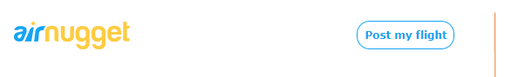
- Add play sign to the video (you find image in folder)
Currently:

Update: Add play button
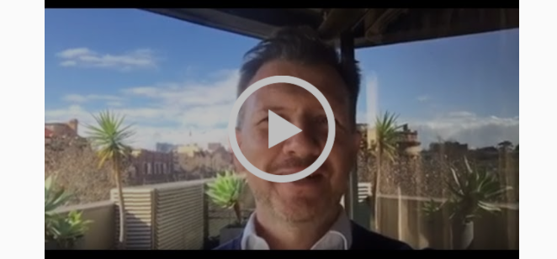

- Add Video link over video
https://www.youtube.com/watch?v=6N30ysTK2Nw
- Button Link URL – Please update as below

https://plus.google.com/116469662694192725459/about
- Update Airbnb to Airnugget
Airnugget HQ
- Logo Link – Add link to Logo

https://airnugget.com/
- Update Content – Please update written content as below
Currently
Founded in december of 2015 and based in hong kong, Airnugget is a trusted community
marketplace for people to post, discover and find unique flights around the world-online or
from a mobile phone or tablet
Whether a business class, low coast, or multi city flight,Airnugget connects people to unique
flight options, at any price point,all around the world.and with world-class costomer service and
a growing community of users, Airnugget is the easiest way for people to monetise there flight
search and showcase it to an audience of millions.
Update:
Airnugget first came about when its founders, were travelling through Asia. They had gotten a great deal on the flight there by booking it as a multi-city itinerary as opposed to a return flight.
They were discussing the low air fare, and how there are thousands of experts discussing similar tricks on open or closed discussion forums on the internet. From there they had the idea of connecting travellers with these experts to help more people travel at a lower cost.
In a nutshell, Airnugget is a crowd-sourced air fare marketplace. By using the knowledge and experience of expert flight searching gurus, we want to provide customers with the best flight deals that may not be as easy for travellers to find themselves.

